Stock Bot

By Nicole Wiechmann

Introduction:

When working on StockBot, I had a lot of challenges. The biggest challenge for me was time management, as I had to work on projects for other classes while also had to write the Research paper for this class. I found myself not realizing just how far behind I was when I started StockBot, as it was the last program I had left for Project 2. I found part 1 and part 2 to be easy, as it just incorporated programs I either already had done or already knew how to do, so I did not have any trouble with that. The problems started with RSI and tradeEvaluator, as I had a lot of problems trying to get them to work.

Collecting Stock Data:

This part was by far the easiest part of the program, as it was mostly just taking information from the CSV file and creating different ArrayLists of the information. First, I found the stock CSV I wanted to use. I decided to use Amazon’s stock data, and imported the CSV file into excel to create graphs of the opening, closing, highs, and lows of all the dates given. The graphs showed altogether that Amazon stocks have been steadily rising through the data frame of the CSV. They did however have a decline around the middle of October of 2023, but they rose back up afterwards to a new high.

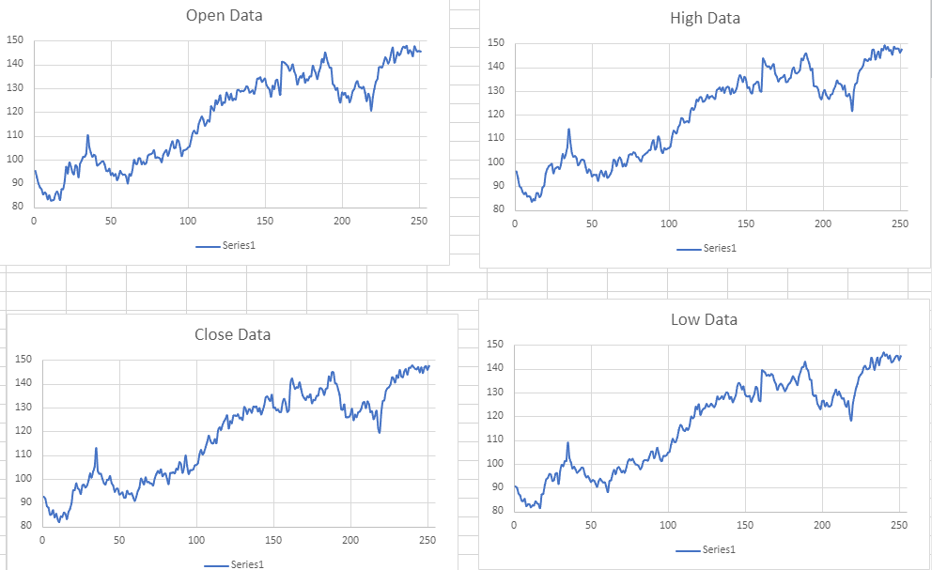

When creating a program collecting the stock data, I mostly just reused code from my smoother and from loading in CSV files from other projects. I created four different arraylists to hold the open, close, high, and low data, in case I needed it for testing and debugging. Next, I recreated my smoother so that it would take in Doubles instead of integer values. Pretty much everything else stayed the same within the actual smoother and I had little to no problems at this point.

Where the Problems Started - RSI Calculations :

Next I worked on doing my RSI calculations. Originally, I thought this part was going to be easy, as it was just taking an equation that already exists and programming it. I decided to do this using a for loop and by looking at the RSI calculations on Macroption. This took me a few tries to get correct and a lot of debugging, but eventually it seemed to work fine and I moved on from the calculations. I later found out it would not print for certain types of stock information, so I once again had to go back and fix it, hoping it would work correctly. As of right now, I believe it works correctly for most types of stock information, but if I had to pick where the problems may lie I believe it is within the starting date chosen.

Trade Evaluation and Debugging:

When creating the tradeEvaluator method, this is where I started to get stuck and having to do more research. This was also when I got stuck because my RSI calculator was not working correctly, and I spent about an hour trying to figure out what was wrong with my tradeEvaluator. Once I realized it was a problem with my RSI calculator, I then had to go back and work on the RSI calculator one last time. This took me a while and debugging did not go too well, as different kinds of data gave me different errors. Eventually, I got to a point where my code did not produce any errors, but instead the tradeEvaluator method would always produce an empty RSI array and would always print out “do nothing”.

Results and What To Improve:

Overall, I enjoyed trying to write this program, but as I stated in the introduction I did not have enough time to fully put myself into this program as I did with everything else for this project. Once this semester is over and I graduate, I would like to eventually come back to this program and work on it more, as I feel like it is good experience to have and would look good to anyone that may be looking through my Github. What I would like to improve the most is my RSI calculator, as I do believe that is where my problems lie within the program. As mentioned above, my results mostly ended with “do nothing” for every stock CSV file I tried to test with, which in a way could be true to real life.

